
Arden University (Berlin)


Artificial Intelligence and Neural Networks

COM7019


Artificial Intelligence and Neural Network Portfolio


24169956


Prof. Mohammad Amin Mohammadi Banadaki


3,295

Table of Contents
- Introduction ----------------------------------------------------------------------------------- 4
- Background and Problem Statement ------------------------------------------------- 4
  - Aim and Objectives ----------------------------------------------------------------------- 5
  - Report Structure --------------------------------------------------------------------------- 6
- Task 1: Neural Network Design, Testing, and Implementation ------ 7
  - Dataset Overview (MNIST) --------------------------------------------------------------- 7
  - Data Preparation and Preprocessing -------------------------------------------------- 8
  - Tools and Environment ------------------------------------------------------------------- 10
  - Model Architecture (Input + Six Hidden Layers + Output) ---------------------- 11
  - Activation Functions (Sigmoid vs Tanh) ---------------------------------------------- 12
  - Output Layer and Probability Distribution ------------------------------------------- 12
  - Training Setup (Loss, Optimizer, Hyperparameters) ------------------------------ 12
  - Results on MNIST (Metrics and Curves) ---------------------------------------------- 13
  - External Testing (Custom Images) ----------------------------------------------------- 15
  - Discussion and Analysis (Sigmoid vs Tanh) ---------------------------------------- 25
  - Task 1 Written Justification ------------------------------------------------------------ 25
- Task 2: Critical Evaluation Report -------------------------------------------------- 27
  - Summary of Technical Findings ---------------------------------------------------------- 27
  - Ethical and Moral Considerations ------------------------------------------------------- 27
  - Reliability, Risk, and Real-World Impact ----------------------------------------------- 28
  - Bias, Fairness, and Accessibility ---------------------------------------------------------- 28
  - Privacy and Security Considerations ---------------------------------------------------- 28
  - Mitigation Strategies ------------------------------------------------------------------------ 29
  - Future Improvements ---------------------------------------------------------------------- 29

- Additional Experiments and Extended Analysis ------------------------------ 30
  - Motivation for Additional Experiments ------------------------------------------------- 30
  - Extended MNIST Results (15 Epochs) ---------------------------------------------------- 30
  - Interpretation of Findings ------------------------------------------------------------------- 36
- Conclusion ----------------------------------------------------------------------------------------- 37
- References ---------------------------------------------------------------------------------------- 38
- Appendices --------------------------------------------------------------------------------------- 39
Appendix A: Full Source Code ------------------------------------------------------------------- 39
Appendix B: GitHub Link & Execution Instructions (How to Run the Project) ------ 51

Introduction
This research focuses on handwritten digit recognition for document processing scenarios in which numbers must be reliably recovered from scanned or photographed data. Although MNIST provides a reliable standard for training and comparison, real-world digit inputs frequently deviate due to background colour, stroke thickness, centring, scaling, and noise. To solve this, I constructed and compared two Multi-Layer Perceptron (MLP) models trained on MNIST, which were then tested on MNIST as well as multiple external/custom picture sets created in various formats.
  - Background and Problem Statement
Digit recognition is an essential part of many automated document operations. The fundamental issue is that digits written by various people—or generated by different sources—can change greatly in shape, thickness, alignment, brightness, and backdrop. Models trained solely on clean datasets may perform well on typical test data but suffer when the input distribution changes, for example, numbers typed in Word with white background and black background as well, drawn in Windows Paint, collected from online resources. (E.g., Freepik, Google Images, Canva), Handwritten digits (0-9) on white paper, including samples recorded under low- and high-brightness conditions.
In this study, I examine how a fully connected neural network (MLP) performs on handwritten digit categorization and how well it generalizes beyond MNIST. I trained the network on MNIST with a stable architecture and training setup, then tested it on external/custom digit pictures stored in the following multiple folders.
                - custom_digits/word_blackbg
                - custom_digits/word_whitebg
                - custom_digits/paint_whitebg
                - custom_digits/online
                - custom_digits/handwritten
This external testing helps to uncover robustness issues and real-world failure cases that are relevant in practical deployment.
  - Aim and Objectives
Aim:
To create, train, and test an MLP-based digit classifier with MNIST, and compare Sigmoid and Tanh hidden-layer activations while evaluating performance on both MNIST and external/custom digit images.
Objectives:
                - Create a Multi-Layer Perceptron using a 784-dimensional input (flattened 28x28 image), six hidden layers, and a 10-class output for numbers 0-9.
                - Train and compare two models, Sigmoid and Tanh, with the only difference being the hidden-layer activation function.
                - Create a class probability distribution using an output-layer arrangement and a Softmax activation function.
                - Train on MNIST with a predefined training setup (epochs, batch size, learning rate) and track learning behaviour using loss/accuracy history.
                - Evaluate performance using standard metrics and visual evidence:
- MNIST loss/accuracy curves are saved in outputs/mnist_sigmoid/ and outputs/mnist_tanh/
- External test results are recorded under outputs/custom_tests/…, which include confusion matrices, classification reports, and per-image prediction visualizations.
                - Examine the observed differences between the Sigmoid and Tanh models, including generalization behaviour and typical failure instances using external/custom inputs.
                - To examine convergence behaviour and generalization performance, run more trials with different activation functions (ReLU and mixed activation configurations) and longer training durations.

  - Report Structure
This report follows this structure: Section 2 explains the datasets and preparation methods for the MNIST dataset and external digit images. Section 3 covers the six-layer MLP architecture, activation functions, training setup, and output formulation. Section 4 presents MNIST training and testing results, including accuracy and loss curves. Section 5 assesses performance on external digit datasets using confusion matrices and classification reports. Section 6 discusses experimental results, highlighting performance variations and constraints, while Section 7 analyzes deployment, reliability, and ethical issues. Additional experiments beyond the baseline are included at the end, followed by a conclusion, appendices, and Harvard-style references.

Task 1: Neural Network Design, Testing, and Implementation
2.1 Data Overview (MNIST)
The MNIST dataset is a popular benchmark for handwritten digit recognition. The grayscale images range from 0 to 9 and are 28x28 pixels in size. MNIST serves as the primary training and testing dataset for this research since it provides a consistent baseline for measuring neural network performance. The dataset is loaded programmatically using torchvision.datasets.MNIST and placed in the local data/directory.
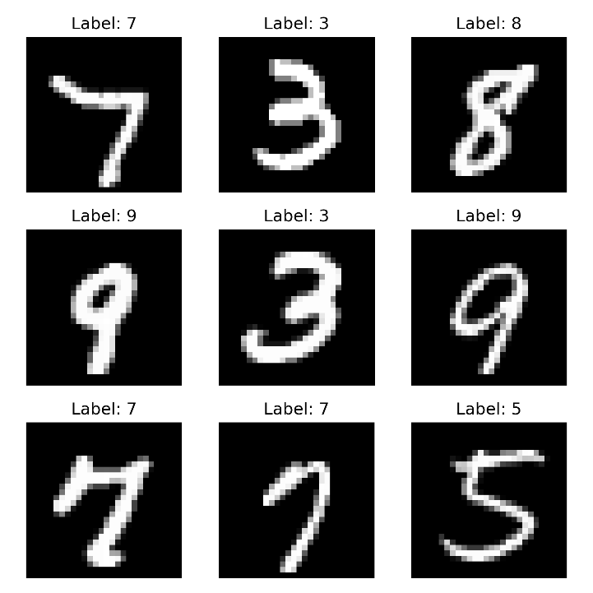
Figure 2.1.1: Sample images from the MNIST dataset (training set), showing handwritten digits (0–9) in 28×28 grayscale format with their corresponding labels.

  - Data Preparation and Preprocessing
MNIST Preprocessing
MNIST preprocessing data using a torchvision transform pipeline. Each image is:
                - Transformed into a tensor using transforms.ToTensor() scales pixel values to [0, 1].
                - Transformed from 28x28 to 784-dimensional vector.Lambda(lambda x: x.view(-1)), as an MLP, requires 1D input features rather than a 2D grid.
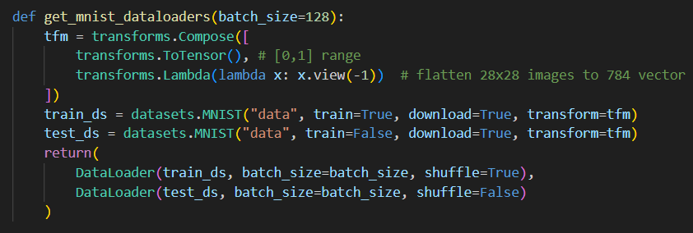
Figure 2.2.1: MNIST data loading and preprocessing (get_mnist_dataloaders())
External/custom image preprocessing
External/custom digit photos require further processing to remove background effects and align with the MNIST input format. The function preprocess_custom_image(), as shown in (Fig, 2.2.2) follows these steps:
- Convert the input image to grayscale and use auto-contrast.
- Automatically invert the image when the mean pixel intensity is high. (To ensure the digit is light on a dark background format when needed).
- Use a MaxFilter(3) to sharpen strokes.
- Convert to NumPy, normalize to [0, 1], and then use a threshold mask (arr > 0.15).
- Use linked component labelling to retain only the largest connected component (which is assumed to be the digit).
- Crop to the digit bounding box, scale to a maximum dimension of 20 pixels, and centre on a 28x28 canvas.
- Apply a final shift with the centre of mass to centre the digit around the MNIST-style middle (14, 14).
- Flatten the 28x28 image to 784 features.
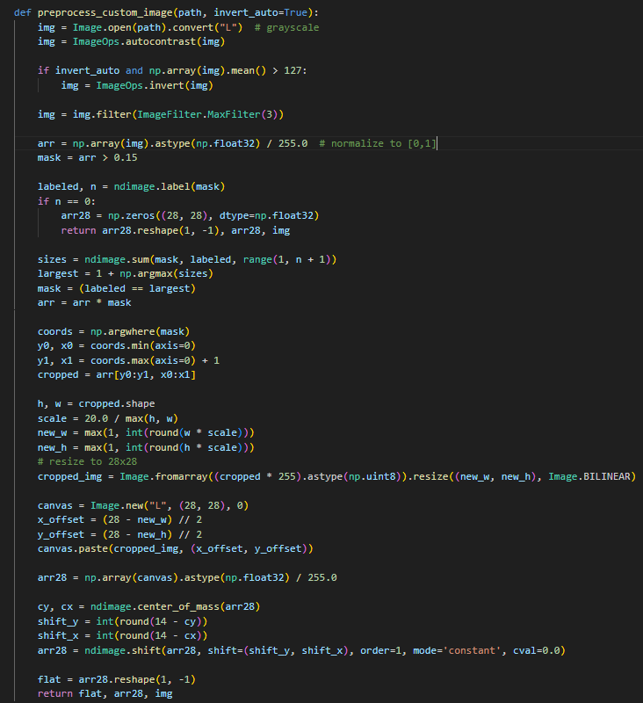
Figure 2.2.2: Custom image preprocessing pipeline (preprocess_custom_image())
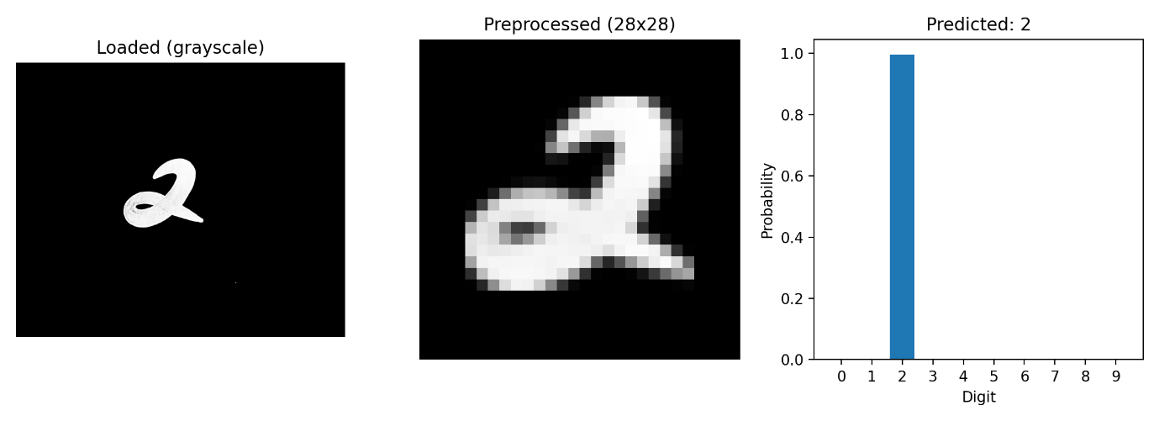
Figure 2.2.3: Example external input (Handwritten) preprocessing result.

  - Tools and Environment
This project is implemented in Python and uses the following main libraries:
- PyTorch (torch, torch.nn) for model definition, training, and inference.
- torchvision (datasets, transforms) for MNIST loading and preprocessing.
- NumPy for array processing and numeric operations.
- SciPy (ndimage) for connected component analysis and centre-of-mass shifting in custom image preprocessing.
- PIL (Pillow) for image loading, inversion, contrast, filtering, resizing, and canvas operations.
- Matplotlib for saving training curves and prediction visualisations.
- scikit-learn metrics for generating confusion matrices and classification reports on external tests.
The training script detects hardware automatically using:
- torch.device(“cuda” if torch.cuda.is_available() else “cpu”)
If no GPU is available, it runs on CPU.

  - Model Architecture (Input + Six Hidden Layers + Output)
An MLP classifier (class MLP) is implemented using nn.Sequential with:
- Input layer: 784 (flattened 28x28)
- Six hidden layers:
    - 784 → 256
    - 256 → 256
    - 256 → 128
    - 128 → 128
    - 128 → 64
    - 64 → 32
- Output layer: 32 → 10 (for digits 0—9)
Each hidden layer uses:
- A chosen activation function (sigmoid or Tanh).
- Dropout = 0.2 for regularisation after each activation.
- The output layer creates a normalized probability distribution across the 10-digit classes by using a Softmax activation function.
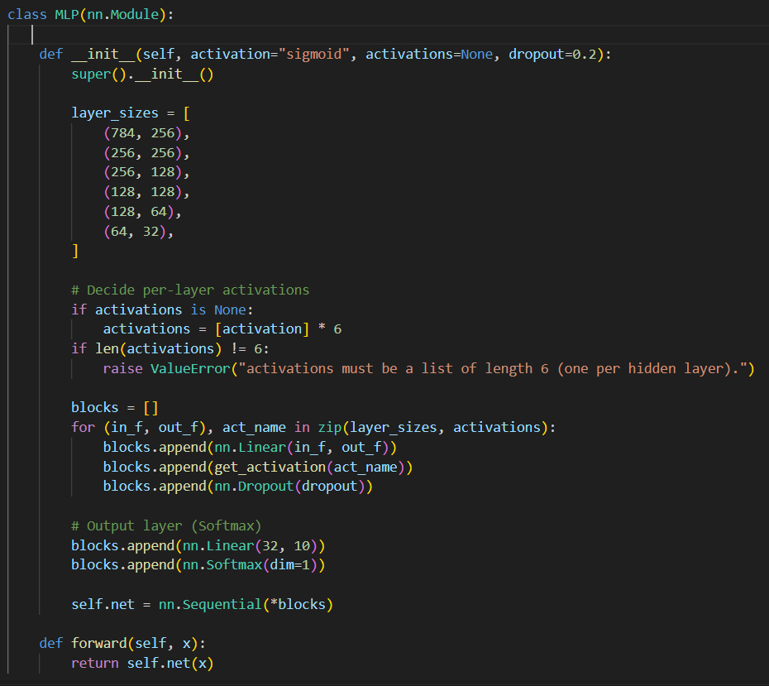
Figure 1.4.1: Implementation of the six-hidden-layer MLP classifier (MLP)
  - Activation Functions (Sigmoid vs Tanh)
This project compares two activation functions in the hidden layers, keeping the rest of the model and training settings constant:
- Sigmoid activation reduces outputs to (0, 1). It can saturate for big positive/negative inputs, slowing learning due to tiny gradients.
- Tanh activation, which squashes outputs to (-1, 1) and is zero-centred, might sometimes improve optimization behaviour compared to Sigmoid.
Two experiments are run:
- MLP with hidden activation = Sigmoid
- MLP with hidden activation = Tanh
This controlled comparison examines the impact of activation choice on convergence and generalization.
  - Output Layer and Probability Distribution
A Softmax activation function is used in the network’s last layer to generate a probability distribution for each of the ten-digit classes (0-9). These probabilities are transformed into log-probabilities during training, and the Negative Log Likelihood Loss (NLLLoss) is used to optimize them. This method maintains the Softmax output criterion while guaranteeing numerical stability. The model explicitly outputs probabilities during inference, allowing for comprehensible confidence scores for every anticipated digit.
  - Training Setup (Loss, Optimizer, Hyperparameters)
As shown in Table 2.7.1 Training is implemented in train_mnist() having:

Parameter | Value
Epochs | 10 (Baseline), 15 (extended experiments)
Batch size | 128
Learning rate | 0.001
Optimizer | Adam
Loss function | NILLoss
Dropout | 0.2
Seed | 42
Device | CUDA if available, else CPU
Table 2.7.1: Training configuration used for MNIST experiments.
Training and test performance are tracked per epoch using:
- Accuracy and loss from run_one_epoch().
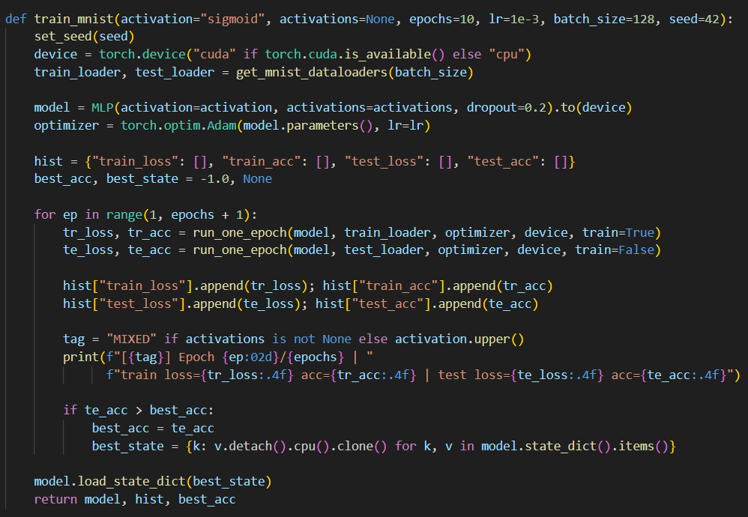
Figure 2.7.1: Key training procedure from train_mnist()
10 epochs were used for the baseline comparison between Sigmoid and Tanh, while 15 epochs were used in the extended studies to further examine convergence behaviour.
  - Results on MNIST (Metrics and Curves)
Model performance on MNIST is recorded as learning curves, with the final best test accuracy:
- Learning curves saved as:
  - outputs/mnist_sigmoid/loss_curve.png and accuracy_curve.png
  - outputs/mnist_tanh/loss_curve.png and accuracy_curve.png
These curves show:
- How quickly each model learns (convergence speed)
- Whether overfitting occurs (gap between train and test curves)
The script also prints the best MNIST test accuracy achieved by each activation after training, as shown in Figure 2.8.1
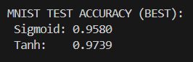
Figure 2.8.1: MNIST test accuracy (BEST)—Epochs 10
Learning curves (Sigmoid)—Epochs 10
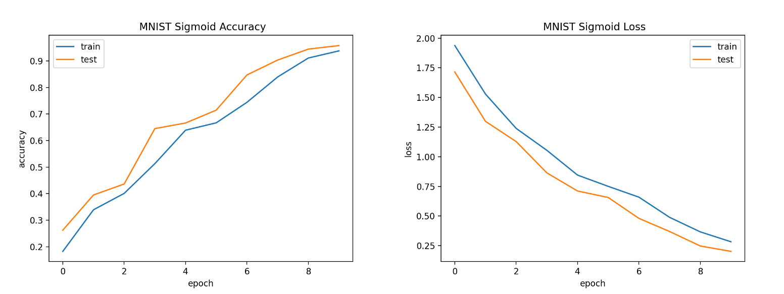
Figure 2.8.2: accuracy and loss curves for Sigmoid
Learning curves (Tanh)—Epochs 10
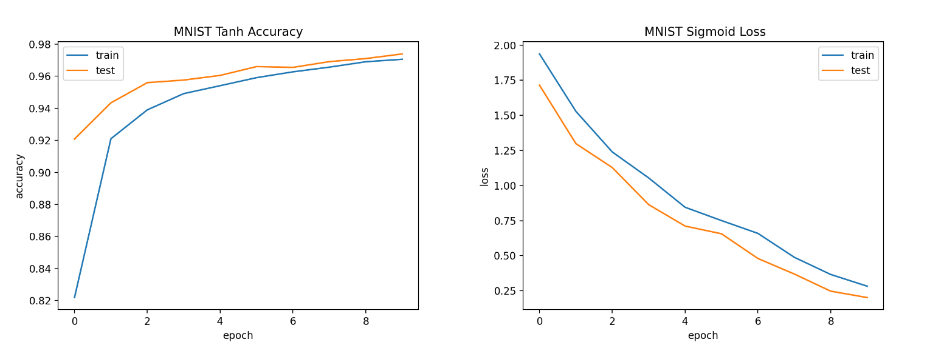
Figure 2.8.3: accuracy and loss curves for Tanh

  - External Testing (Custom Images)
To assess real-world resilience, both models are evaluated using external/custom digitized images stored in:
- custom_digits/word_blackbg
- custom_digits/word_whitebg
- custom_digits/paint_whitebg
- custom_digits/online
- custom_digits/handwritten
Ground-truth labels are automatically retrieved from file names (e.g., 3_handwritten_02.jpg → true label = 3). For every dataset, the system saves:
- Confusion matrix: confusion_matrix.png
- Classification report: classification_report.txt
- Per-image visualization: *_prediction.png (Loaded image, Preprocessed 28x28, Probability bar chart)
Summary of external test accuracy
External set | Sigmoid Accuracy | Tanh Accuracy
handwritten (62 images) | 0.5000 | 0.5161
online (69 images) | 0.5652 | 0.6667
paint_whitebg (28 images) | 0.8929 | 0.9643
word_whitebg (10 images) | 0.7000 | 0.8000
word_blackbg (10 images) | 0.7000 | 0.8000
Table 2.9.1: Classification Report (Sigmoid vs Tanh)—Epochs 10
Tanh outperforms all external test sets, with the most significant improvement seen on the online and paint_whitebg datasets. The handwritten set remains difficult for both models, indicating a larger domain shift (variation in handwriting style, lighting, and stroke structure).
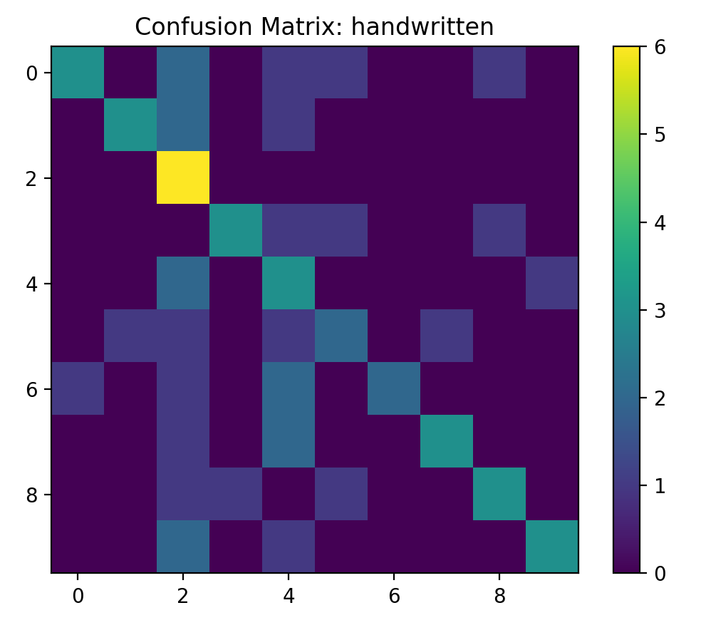
Figure 2.9.1: Confusion Matrix: handwritten (Sigmoid)—Epochs 10
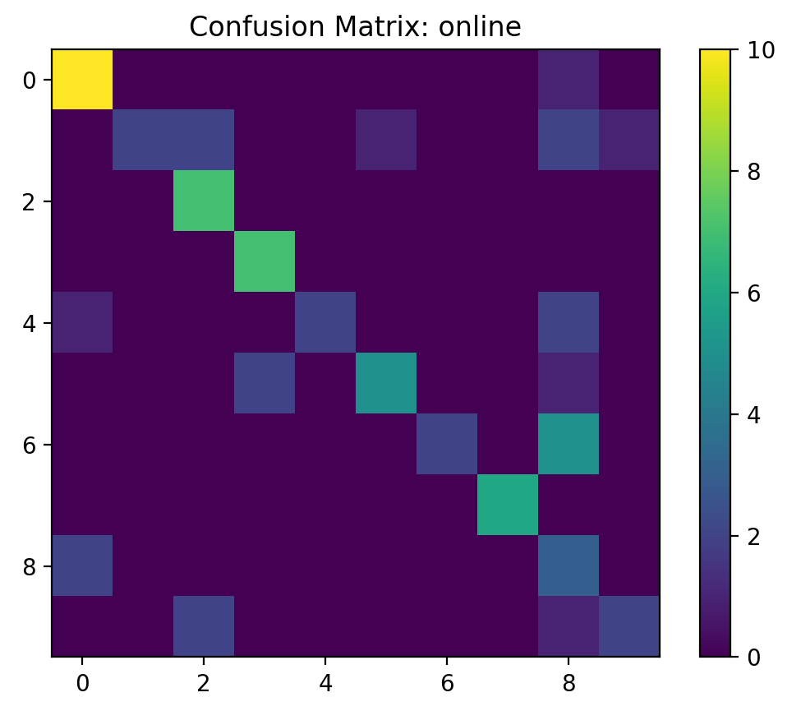
Figure 2.9.2: Confusion Matrix: online (Tanh)—Epochs 10
handwritten—Sigmoid (Output)
Input | Output | Classified | Reason
0 | 0 | ✅ | Taken from the iPhone's built-in scanned feature, handwritten digits. demonstrating the model’s ability to generalize when the digit is clear and well-centred after preprocessing.
1 | 1 | ✅
5 | 7 | ❌ | Capture using a mobile camera in low light. This sample was misclassified most likely due to light noise, diminished contrast, and partial digit loss during preprocessing.
Table 2.9.1: handwritten—Sigmoid (Output)—Epochs 10
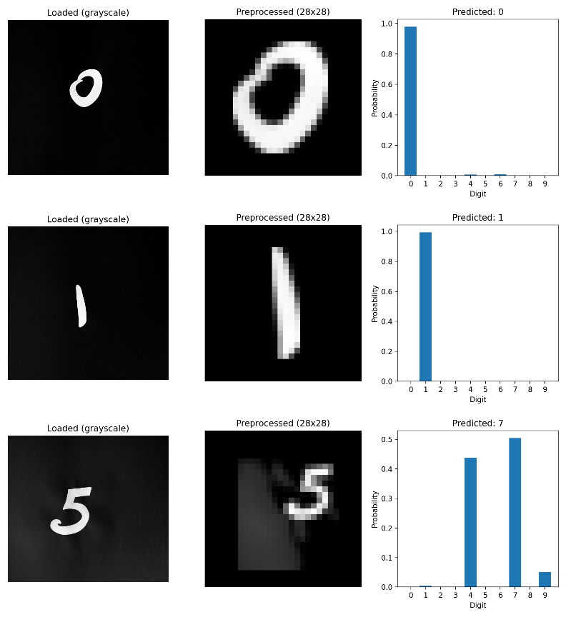
Figure 2.9.3: handwritten—Sigmoid (output)—Epochs 10
handwritten—Tanh (Output)
Input | Output | Classified | Reason
2 | 2 | ✅ | iPhone scan (handwritten), correctly classified as (2, 3) after preprocessing
3 | 3 | ✅
4 | 6 | ❌ | Captured with a regular camera in a low-light environment. Misclassified due to low contrast and noise affecting digit extraction.
Table 2.9.2: handwritten—Tanh (Output)—Epochs 10
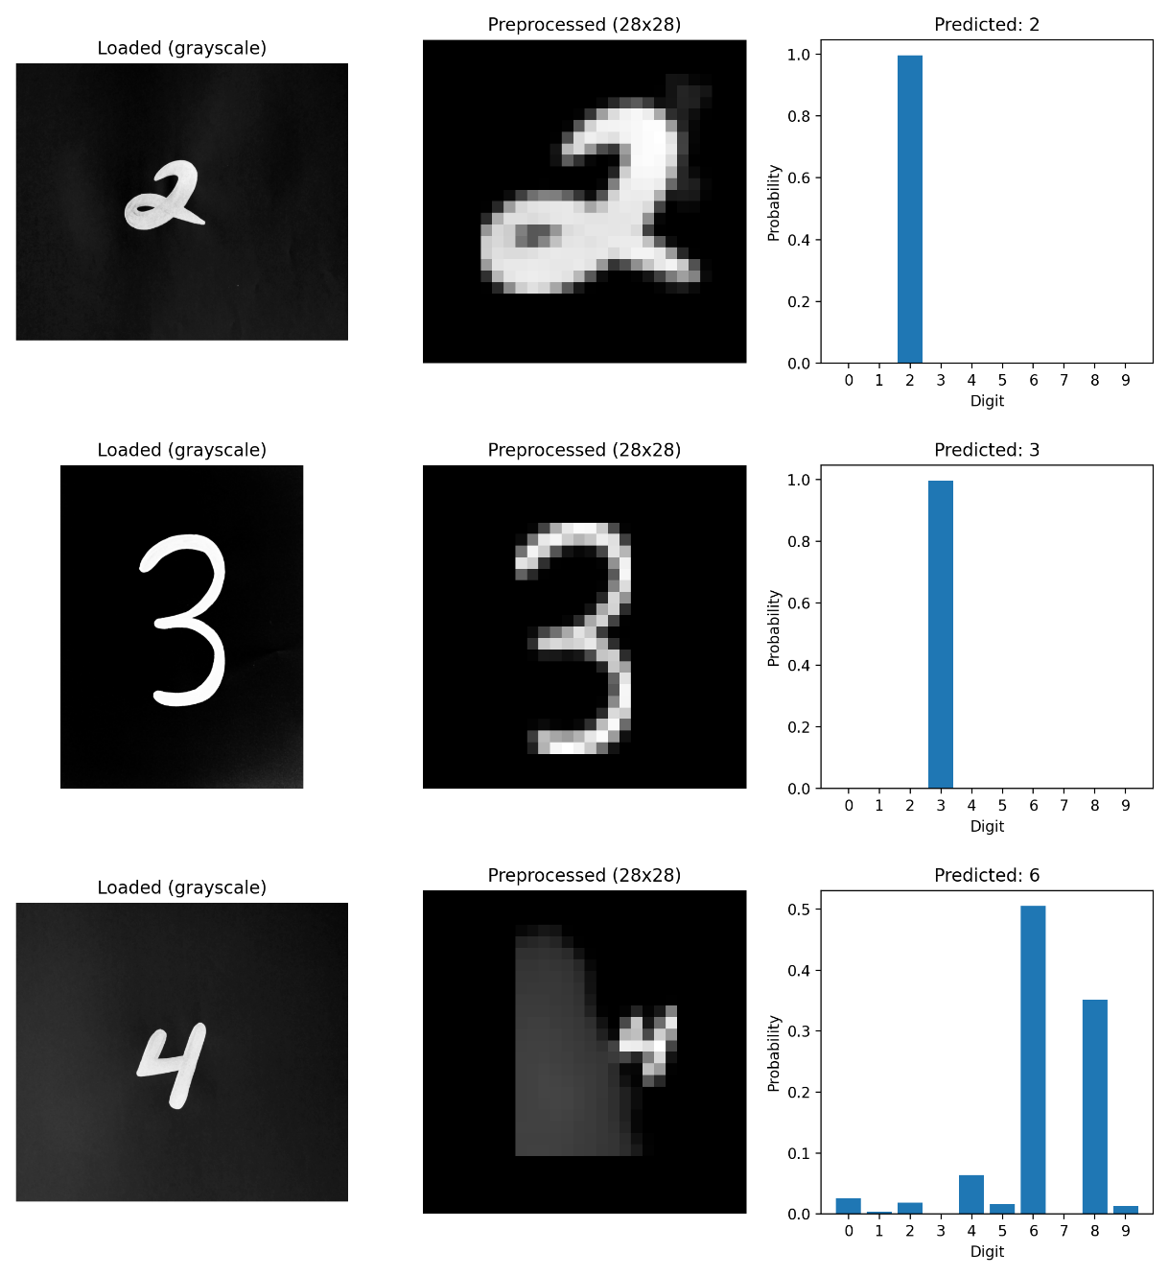
Figure 2.9.4: handwritten—Tanh (output)—Epochs 10
online—Sigmoid (Output)
Input | Output | Classified | Reason
4 | 4 | ✅ | Downloaded from online resources like Google Images/Canva/Freepik. The model accurately classifies both digitally produced digits (4, 5) with strong foreground-background contrast and well-formed digits after preprocessing to 28x28 in sigmoid.
5 | 5 | ✅
6 | 8 | ❌ | Downloaded from online resources like Google Images/Canva/Freepik. This sample was misclassified most likely due to deviations from MNIST in font style, stroke thickness, smoothing/anti-aliasing, or preprocessing errors (e.g., scaling and centring), which can affect digit form and lower classification reliability.
Table 2.9.3: online—Sigmoid (output)—Epochs 10
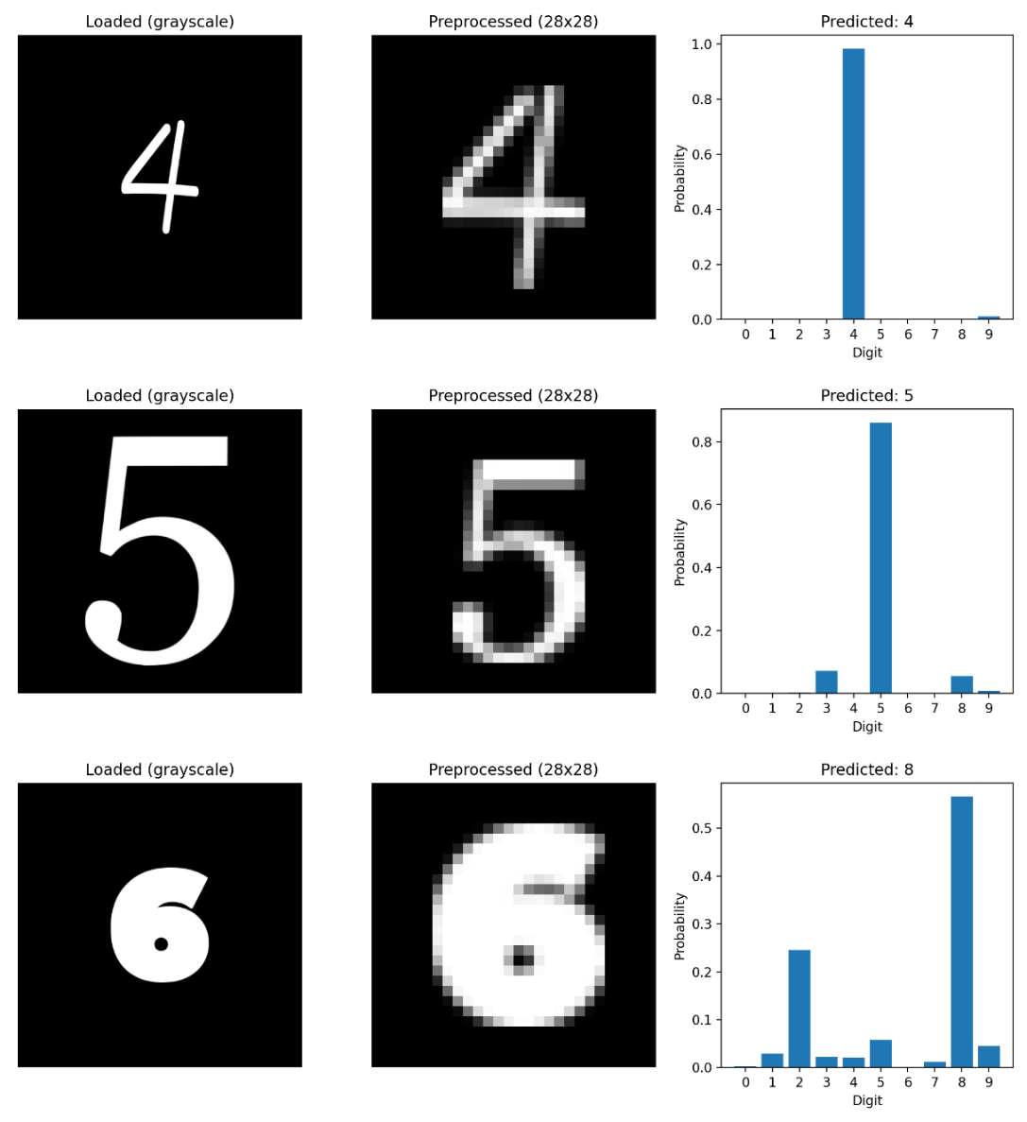
Figure 2.9.5: online—Sigmoid (output)—Epochs 10
online—Tanh (Output)
Input | Output | Classified | Reason
6 | 6 | ✅ | Downloaded from online resources like Google Images/Canva/Freepik. The Tanh-based model accurately classifies digitally produced digits (6, 7) with unambiguous shapes after preprocessing to 28x28.
7 | 7 | ✅
8 | 0 | ❌ | Downloaded from online resources like Google Images/Canva/Freepik. This sample is misclassified as 0 while the input was 8 in outline style and thickness from MNIST handwriting. After resizing and centring, the resultant 28x28 representation becomes ambiguous, confusing with visually similar classes.
Table 2.9.4: online—Tanh (output)—Epochs 10
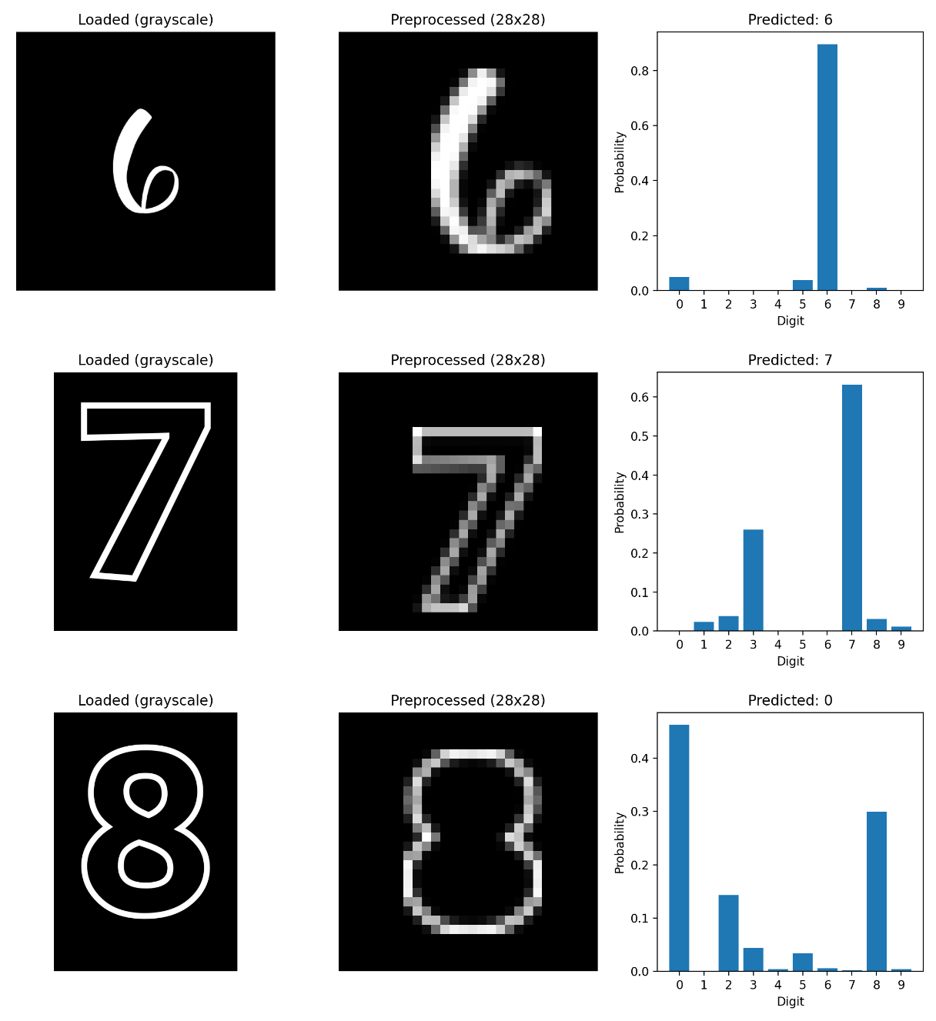
Figure 2.9.6: online—Tanh (output)—Epochs 10
paint_whitebg—Sigmoid (Output)
Input | Output | Classified | Reason
8 | 8 | ✅ | The digits were hand-drawn in Microsoft Paint using a mouse. The sigmoid-based model correctly identifies, showing good generalization to high-contrast, well-centred digital inputs after 28×28 preprocessing.
9 | 9 | ✅
9 | 8 | ❌ | This digit, drawn in Paint with a mouse, is misclassified by the sigmoid model, likely due to thick strokes and shape distortion. After resizing and centring to 28×28, the digit becomes visually ambiguous and overlaps with similar classes.
Table 2.9.5: paint_whitebg—Sigmoid (output)—Epochs 10
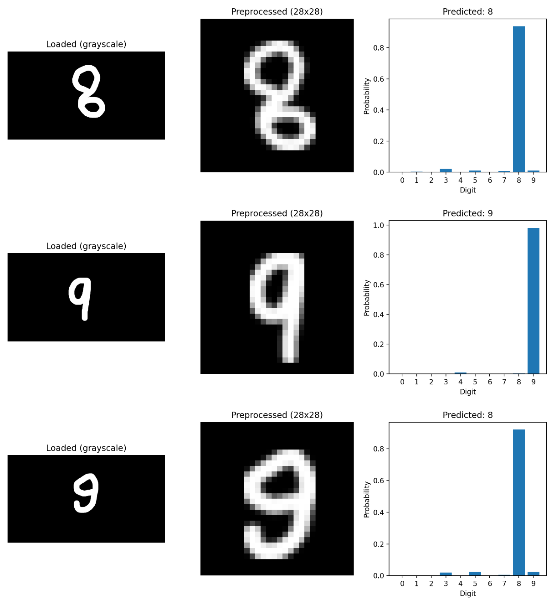
Figure 2.9.7: paint_whitebg—Sigmoid (output)—Epochs 10
paint_whitebg—Tanh (Output)
Input | Output | Classified | Reason
0 | 0 | ✅ | The digits were hand-drawn in Paint using a mouse. The tanh-based model correctly identifies, indicating good generalization to high-contrast, well-centred digital inputs after 28×28 preprocessing.
7 | 7 | ✅
6 | 8 | ❌ | Digit (6), drawn in Paint with a mouse, is misclassified as 8 by the tanh model, likely due to thick strokes and shape similarity. After resizing and centring to 28×28, the digit becomes visually ambiguous and overlaps with similar classes.
Table 2.9.6: paint_whitebg—Tanh (output)—Epochs 10
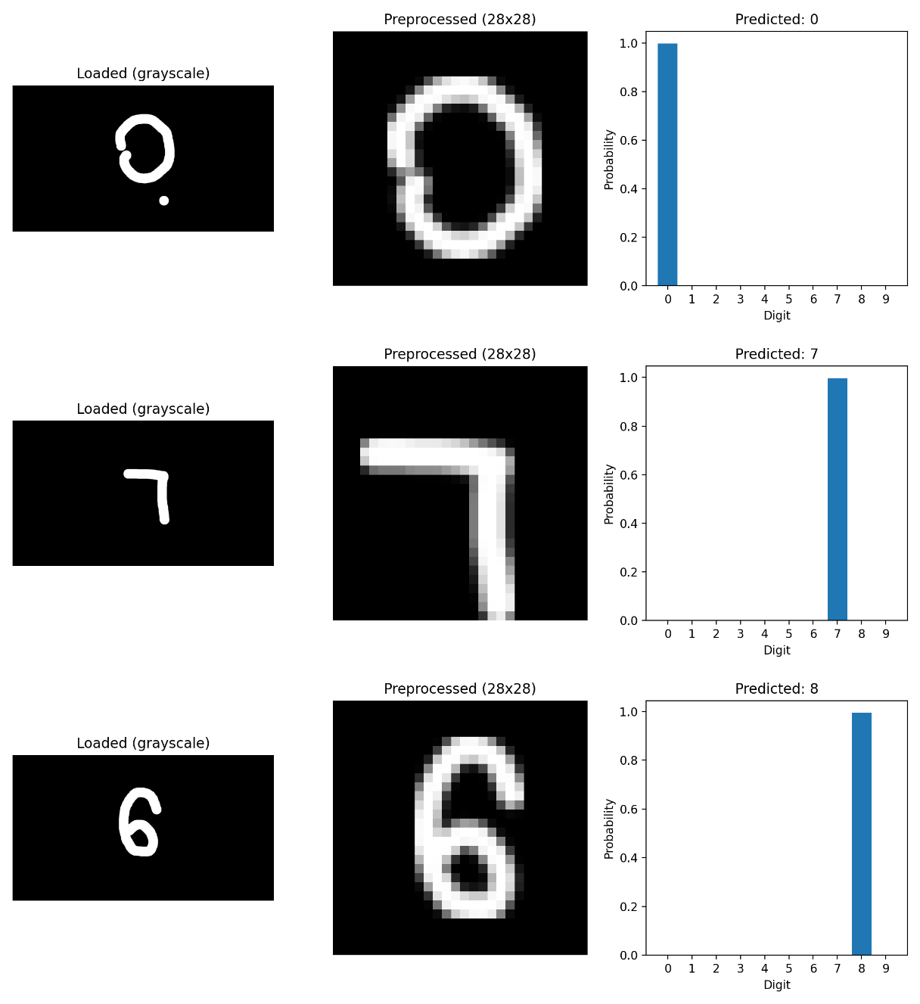
Figure 2.9.8: paint_whitebg—Tanh (output)—Epochs 10
word_blackbg—Sigmoid (Output)
Input | Output | Classified | Reason
4 | 4 | ✅ | Digits were made in MS Word on a black background with the Arial font at size 200. The Sigmoid-based model accurately classifies 4 and 8 after preprocessing to 28x28.
8 | 8 | ✅
1 | 7 | ❌ | The MS Word digit (Arial, size 200) is misclassified as 7 instead of 1, likely due to preprocessing artefacts. Contrast inversion, resizing, and centring introduce a top stroke that makes “1” resemble “7” in the 28×28 representation.
Table 2.9.7: word_blackbg—Sigmoid (output)—Epochs 10
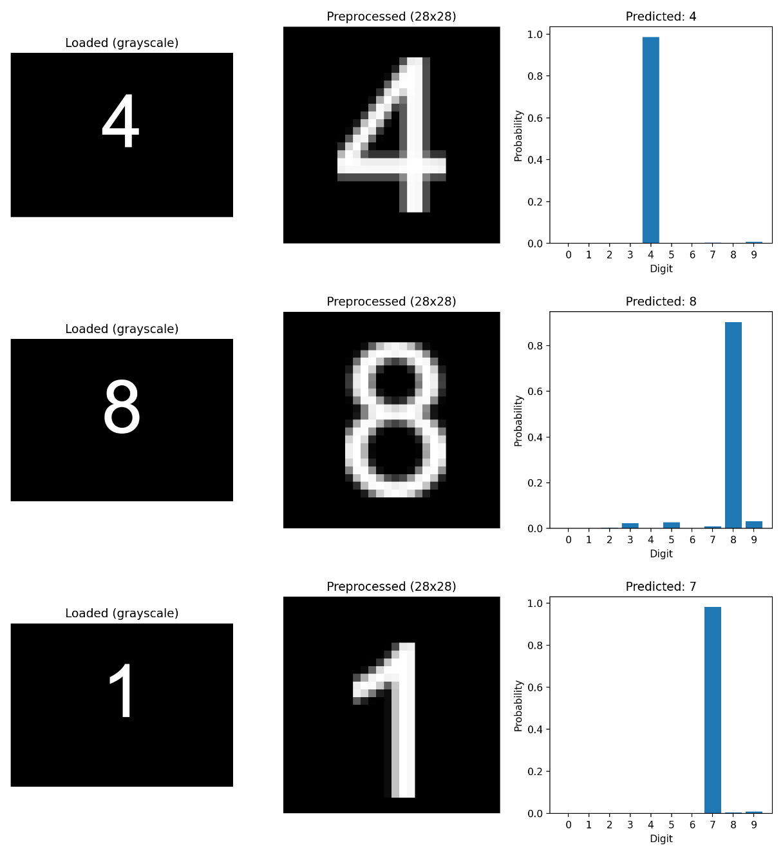
Figure 2.9.9: word_blackbg—Sigmoid (output)—Epochs 10
word_whitebg—Tanh (Output)
Input | Output | Classified | Reason
1 | 1 | ✅ | Digits created in MS Word (Arial, size 200, white background) are correctly classified as 1 and 3 by the tanh-based model after 28×28 preprocessing.
3 | 3 | ✅
9 | 8 | ❌ | Word digit is misclassified as 8, while the white-background version of “1” is correctly identified. This indicates that background color affects preprocessing (contrast, inversion, thresholding), altering edge structure and leading to different classifications for the same digit.
Table 2.9.8: word_whitebg—Tanh (output)—Epochs 10
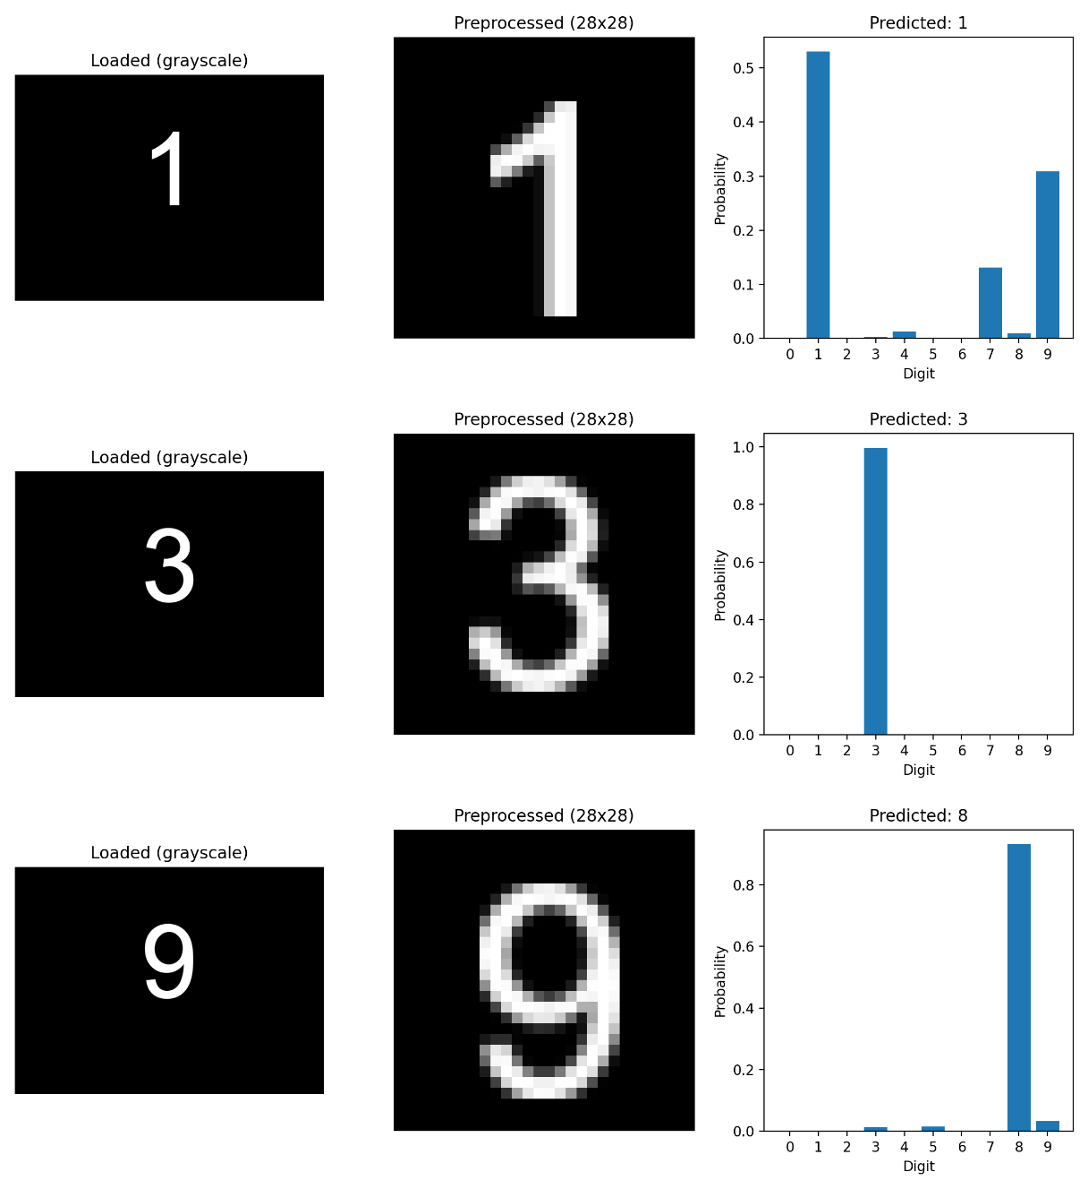
Figure 2.9.10: word_whitebg—Tanh (output)—Epochs 10
  - Discussion and Analysis (Sigmoid vs Tanh)
The MNIST curves show that both networks trained well; external testing reveals that when the input deviates from MNIST, performance declines. This is anticipated since, even after preprocessing, external digits differ in brightness, background, thickness, and alignment.
The Tanh model is more general than the sigmoid across all external datasets. Tanh’s zero-centeredness, which can result in more stable optimization when compared to sigmoid in vast fully connected networks, is probably the cause. The handwritten and online sets still exhibit lower accuracy despite the preprocessing pipeline (auto-contrast, optional inversion, denoising/filtering, biggest component extraction, scaling, and centring), indicating that the MLP approach is sensitive to minute shape and style variations.
One major drawback is that spatial relationships are not explicitly modelled because the MLP flattens pictures into 1D vectors. In the future, robustness on real-world digit inputs might be enhanced by a CNN-based model or more robust data augmentation.
2.11 Task 1 Written Justification
The goal of this research is to compare hidden-layer activation functions under controlled settings by implementing and assessing a Multi-Layer Perceptron (MLP) for handwritten digit recognition using MNIST. Each MNIST image is transformed into a tensor and flattened into a 784-dimensional vector via the data pipeline. MNIST images are 28x28 grayscale digits. Because an MLP expects a 1D feature vector rather than a 2D pixel grid, flattening is required. The selected model architecture complies with the assignment criteria, which call for an output layer, six hidden layers, and an input layer. In particular, the network employs layer sizes of:
784 → 256 → 256 → 128 → 128 → 64 → 32 → 10
Applies dropout (0.2) following each activation to discourage reliance on a small population of neurons, hence reducing overfitting.
Two models were trained with the same hyperparameters but different hidden activations—Sigmoid in one run and Tanh in the other—to isolate the impact of activation functions. In deeper networks, sigmoid compression of activations into (0, 1) might saturate and decrease gradient magnitudes. Tanh is zero-centered and generates outputs in (-1, 1), which can facilitate more stable optimization in real-world scenarios. The output layer applies a Softmax activation function to produce class probabilities, and the Negative Log Likelihood Loss is applied to the logarithm of these probabilities during training. Interpretable confidence scores are made possible by exponentiating log-probabilities to obtain a genuine probability distribution over classes during inference.
The Adam optimizer is utilized for training with a batch size of 128, 10 epochs, and a learning rate of 1e-3. Accuracy and loss are calculated on training and test sets each epoch to analyze convergence and generalization. Learning curves for both the sigmoid and Tanh models are saved as loss_curve.png and accuracy_curve.png. The project includes external testing for real-world resilience alongside the MNIST dataset. A specialized preprocessing pipeline processes custom digit images from various folders (Word, Paint, Online, Handwritten), applying techniques like auto contrast, cropping, scaling to 20 pixels, and centering in a 28x28 canvas, while preserving the digit's structure.
Confusion matrices, classification reports, and per-image prediction visualizations that display the loaded picture, the processed 28x28 digit, and the output probability distribution are produced by external assessments. The findings show that while both models still struggle with handwritten images, Tanh regularly outperforms Sigmoid on external testing, particularly for online and paint datasets. These results demonstrate the limitations of flattening-based MLPs when dealing with real-world digit variability and imply that activation choice influences generalization under domain change.
To further examine convergence and generalization behavior, more experiments utilizing ReLU and mixed activation configurations, along with longer training times, are provided in a later section.

Task 2: Critical Evaluation Report
3.1 Summary of Technical Findings
A fully connected Multi-Layer Perceptron (MLP) intended for handwritten digit recognition served as the foundation for the developed system. The MNIST dataset, a popular benchmark in image classification research, was the main tool used to train and assess the model. As needed, the same network architecture and training configuration were used to develop and compare Sigmoid and Tanh activation functions. Multi-class classification spanning ten-digit categories was made possible by the network's Softmax output layer, which generated class probabilities.
According to experimental results, when trained under the same settings, the Tanh activation function consistently outperformed Sigmoid in terms of accuracy and convergence speed. Although both models performed well on the MNIST dataset, additional testing on external handwritten and online digit datasets showed a discernible decline in accuracy. These results show that while the model works well in controlled benchmark settings, its capacity to generalize to a wider range of real-world inputs is still constrained.
3.2 Ethical and Moral Considerations
Real-world uses for automated digit recognition systems include financial data entry, administrative processing, and educational evaluations. When automated decisions take the place of or greatly impact human judgment, the deployment of such systems presents ethical questions. The model performs significantly worse on handwritten inputs than benchmark data, according to the experimental results. This underscores the possibility of inaccurate classifications when the system is implemented without supervision.
Users whose handwriting deviates from normal patterns may be unfairly disadvantaged by the deployment of a system with known performance limits. As a result, it is morally required of developers to evaluate system constraints and make sure that the necessary precautions are in place. Transparency in system accuracy and the consequences of misclassification are crucial.
3.3 Reliability, Risk, and Real-World Impact
Despite the trained models' great accuracy on the MNIST dataset, these outcomes may not accurately represent reliability in the real world. Reduced accuracy was found in external testing on handwritten and online datasets, suggesting susceptibility to image quality, noise, and writing style.
Misclassification can lead to inaccurate data entry, administrative mistakes, or user annoyance in real-world settings. Softmax probabilities might lead to a false sense of confidence since the model always produces a prediction. These hazards highlight the significance of verifying machine learning systems outside of lab settings and thoroughly evaluating their effects before using crucial applications.
3.4 Bias, Fairness, and Accessibility
When training data does not fully capture the diversity of real-world inputs, bias in machine learning systems frequently results. People's handwriting differs greatly from one another because of things like age, education, cultural background, and motor skills. The algorithm may favor writing styles that are comparable to those in the training data, according to observed performance discrepancies. When automated systems perform inconsistently across user groups, accessibility issues can arise. Users with non-standard handwriting or motor disabilities may be at a disadvantage due to decreased accuracy.
3.5 Privacy and Security Considerations
Real-world digit recognition systems frequently handle user-generated data that may be private or secret, even if the MNIST dataset itself does not contain sensitive personal information. Exam scripts, official documents, and financial records may contain images of handwritten numbers.
Storing and sending photos raises the possibility of misuse, unauthorized access, and data breaches if such data is handled improperly or is not adequately safeguarded. Even anonymized data can pose risks when combined with other information sources. These factors emphasize the necessity of stringent access controls and safe data handling procedures when using digital recognition systems in practical settings.
3.6 Mitigation Strategies
Several mitigation strategies can be employed to reduce the risks identified in this study. One strategy is human-in-the-loop validation, which involves a human operator reviewing computerized predictions, especially in high-risk situations. By designating low-confidence outputs for manual review, confidence thresholds can also assist stop the algorithm from producing erroneous forecasts.
Expanding training datasets to incorporate a wider variety of handwriting styles and noise circumstances can help achieve more mitigation. Emerging vulnerabilities can be found with the use of input validation and ongoing system performance monitoring following deployment. Together, these tactics increase dependability while maintaining the accountability and transparency of automated choices.
3.7 Future Improvements
Future research can concentrate on strengthening the robustness and performance of the model through architectural improvements. Because they retain spatial information, Convolutional Neural Networks (CNNs) are well-suited for image-based applications, which may increase handwritten digit recognition accuracy. Techniques for augmenting data, such as rotation and distortion, may further improve the model's ability to generalize inputs from the actual world.
Reliability could be improved by testing on larger, more diverse datasets and applying long-term performance monitoring. These enhancements would help digit recognition technologies be used more responsibly and ethically.

Additional Experiments and Extended Analysis
  - Motivation for Additional Experiments
Additional experiments were conducted to analyze model behavior beyond the baseline comparison of Sigmoid and Tanh activation functions. These experiments aimed to assess the impact of longer training times and varied activation function choices on convergence speed, final accuracy, and generalization performance. The focus was to understand how architectural and training differences influence performance in fully connected neural networks rather than optimizing the model further.
  - Extended MNIST Results (15 Epochs)
- Sigmoid improves from ~95.7% ~96.8%
- Tanh stabilizes around ~97.6%
- ReLU reaches ~98.1%
- Mixed activations perform competitively but not better than pure ReLU.
ReLU scored the highest MNIST accuracy, suggesting faster convergence and better gradient flow in deeper fully connected networks, while Sigmoid and Tanh saw only a slight increase when training was extended to 15 epochs.
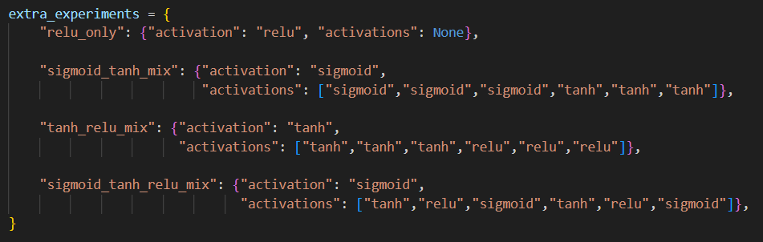
Figure 4.2.1: Additional activation function configurations used for extended experimental evaluation.
Mixed activation configurations, including combinations of Sigmoid, Tanh, and ReLU, showed competitive results, though they did not outperform the pure ReLU model. While longer training times benefit slower activations like Sigmoid, ReLU remains superior for achieving higher accuracy in fewer epochs.
Accuracy Summary—Epochs 15
Model | handwritten | Online | paint_whitebg | word_blackbg | word_whitebg
relu_only | 0.5484 | 0.6522 | 0.9643 | 0.8 | 0.8
sigmoid | 0.5 | 0.6087 | 0.8929 | 0.7 | 0.7
sigmoid_tanh_mix | 0.5161 | 0.6812 | 0.9643 | 0.9 | 0.9
sigmoid_tanh_relu_mix | 0.5323 | 0.6232 | 0.9643 | 0.7 | 0.7
tanh | 0.5323 | 0.6522 | 0.9643 | 0.7 | 0.7
tanh_relu_mix | 0.5484 | 0.6377 | 0.9643 | 0.8 | 0.8
Table 4.2.1: Accuracy Summary (15 Epochs)

Comparison of best MNIST test accuracies for Sigmoid, Tanh, ReLU, and mixed activation function models trained for 15 epochs.
Model | Best MNIST Test Accuracy
sigmoid | 0.9685
tanh | 0.9763
relu_only | 0.9807
sigmoid_tanh_mix | 0.9755
tanh_relu_mix | 0.9769
sigmoid_tanh_relu_mix | 0.9768
Table 4.2.2: Best MNIST Accuracy—(15 Epochs)

ReLU (Curves & Custom Tests Outputs)
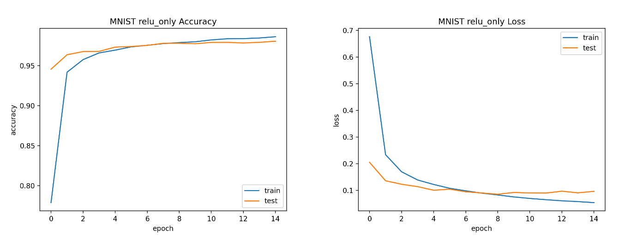
Figure 4.2.2: Accuracy & Loss Curves (ReLU)—15 Epochs

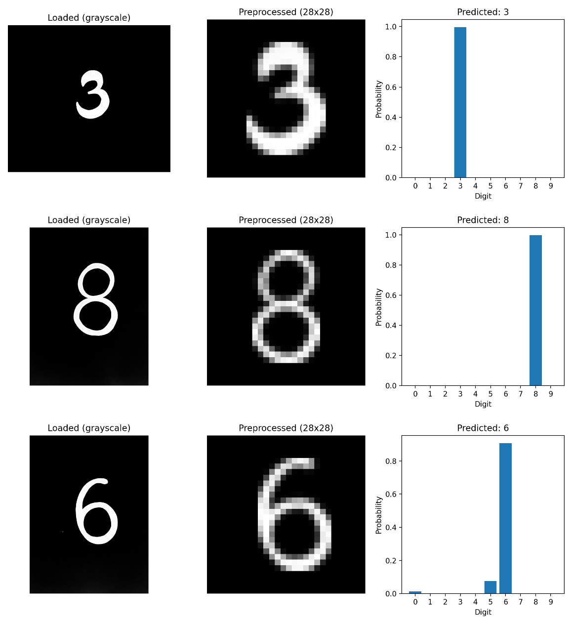
Figure 4.2.3: Handwritten (Output)—ReLU
Sigmoid + Tanh (Curves & Custom Tests Outputs)
- "sigmoid", "sigmoid", "sigmoid" ,"tanh" + "tanh" "tanh"
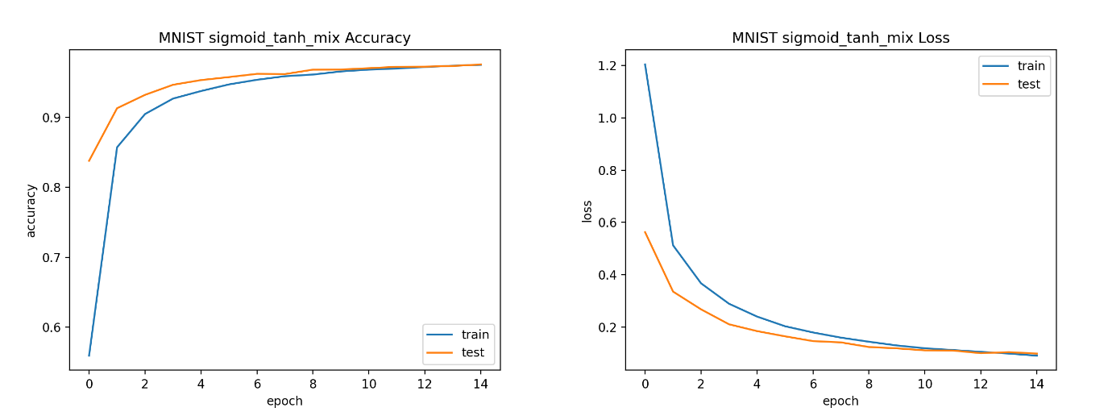
Figure 4.2.4: Accuracy & Loss Curves (Sigmoid + Tanh)—15 Epochs
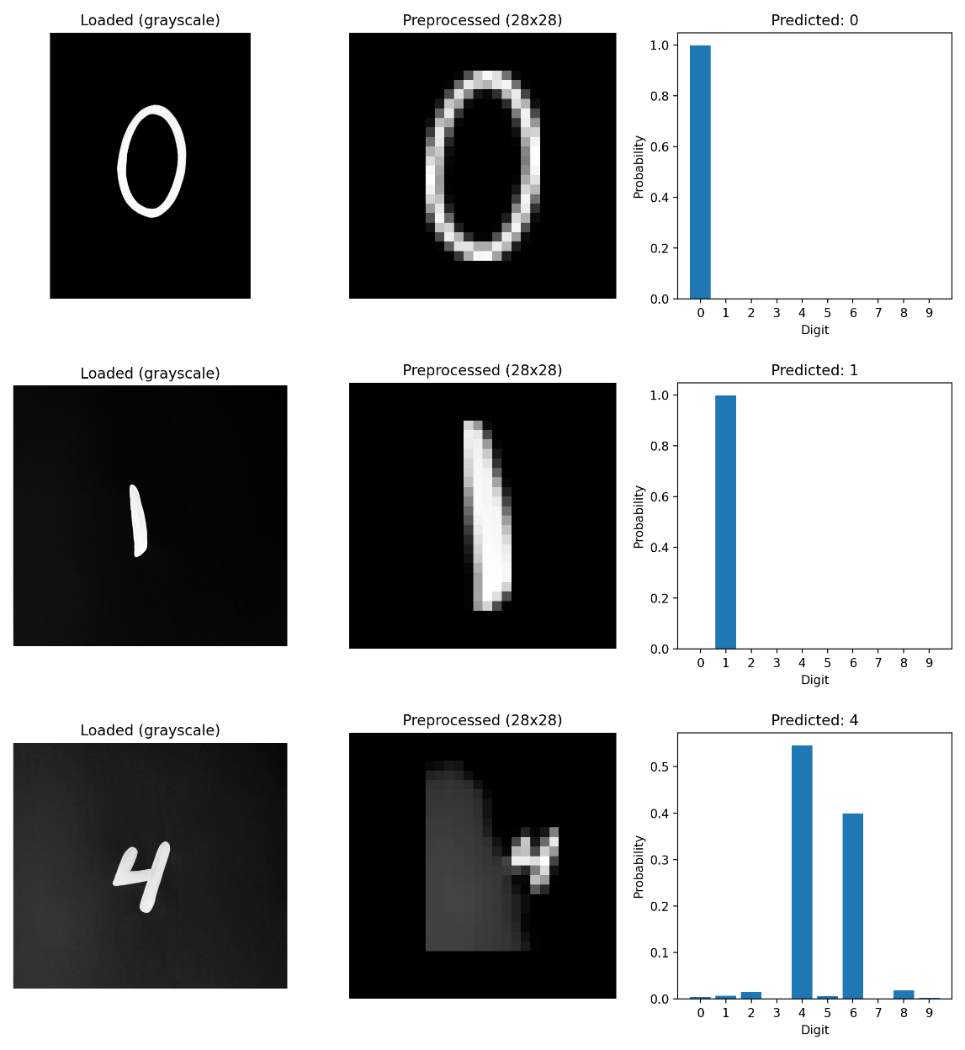
Figure 4.2.5: Handwritten (Output)—Sigmoid + Tanh
Sigmoid + Tanh + ReLU (Curves & Custom Tests Outputs)
- "tanh", "relu", "sigmoid", "tanh", "relu", "sigmoid"
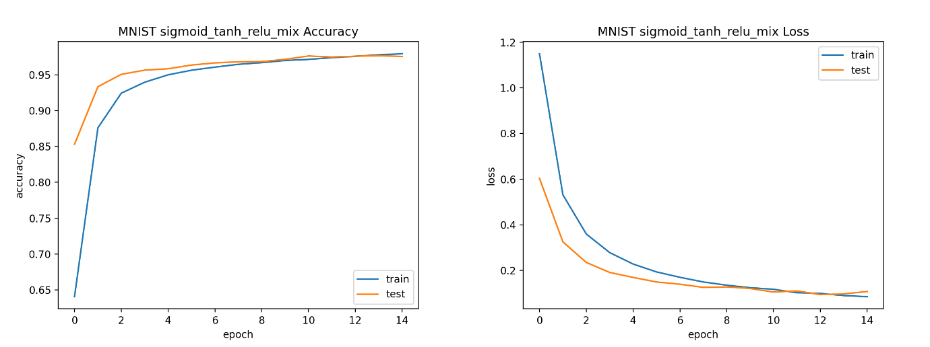
Figure 4.2.6: Accuracy & Loss Curves (Sigmoid + Tanh + ReLU)—15 Epochs
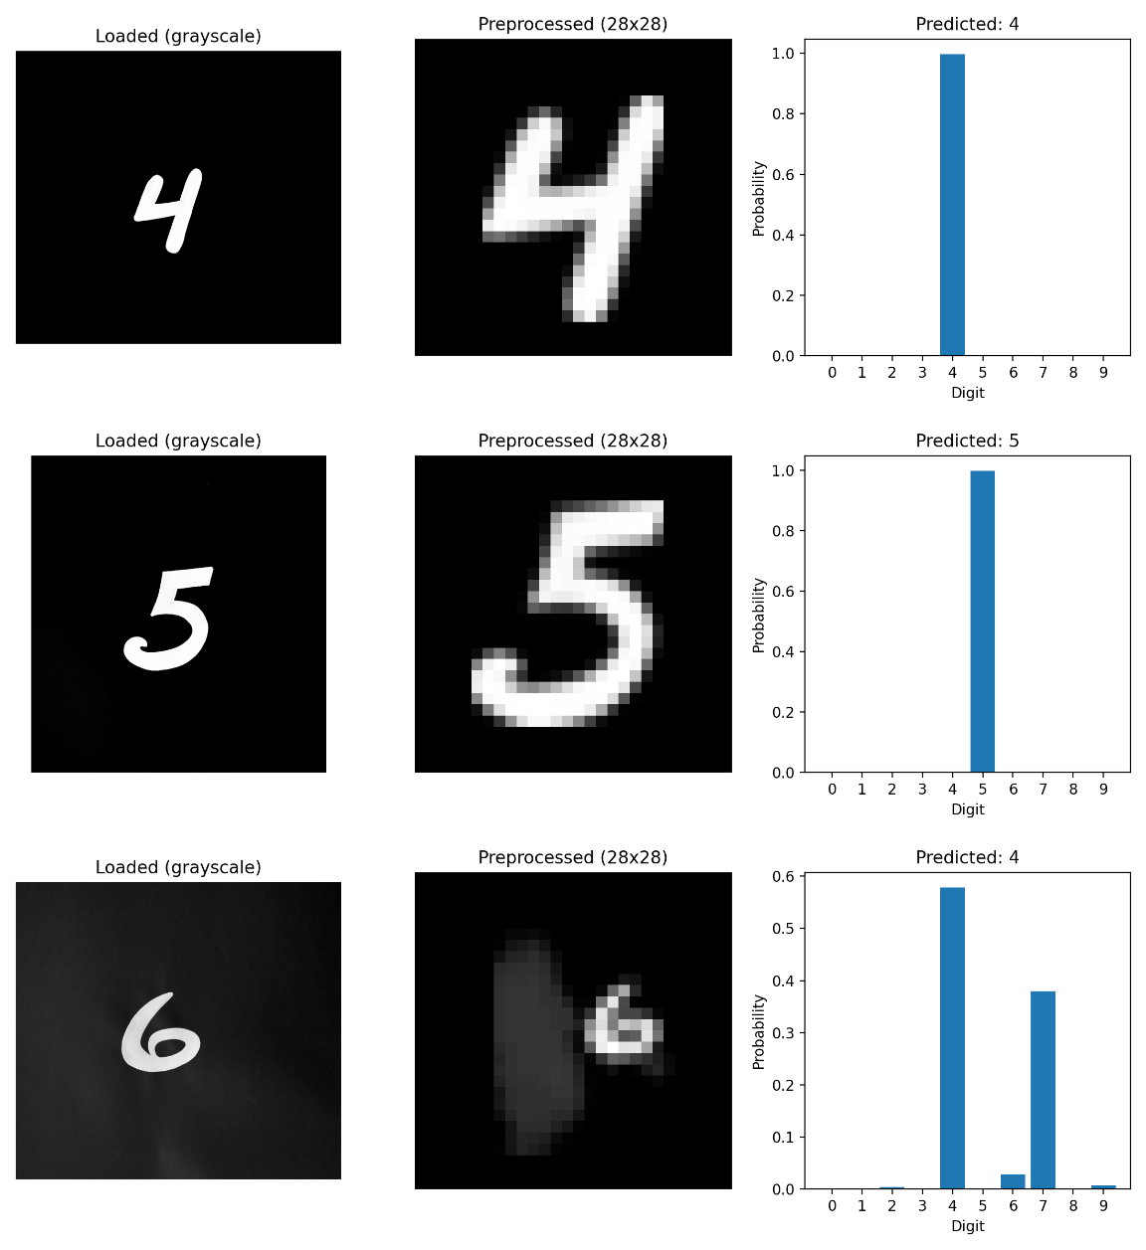
Figure 4.2.7: Handwritten (Output)—Sigmoid + Tanh + ReLU
Tanh + ReLU (Curves & Custom Tests Outputs)
- "tanh" "tanh" "tanh" "relu" "relu" "relu"
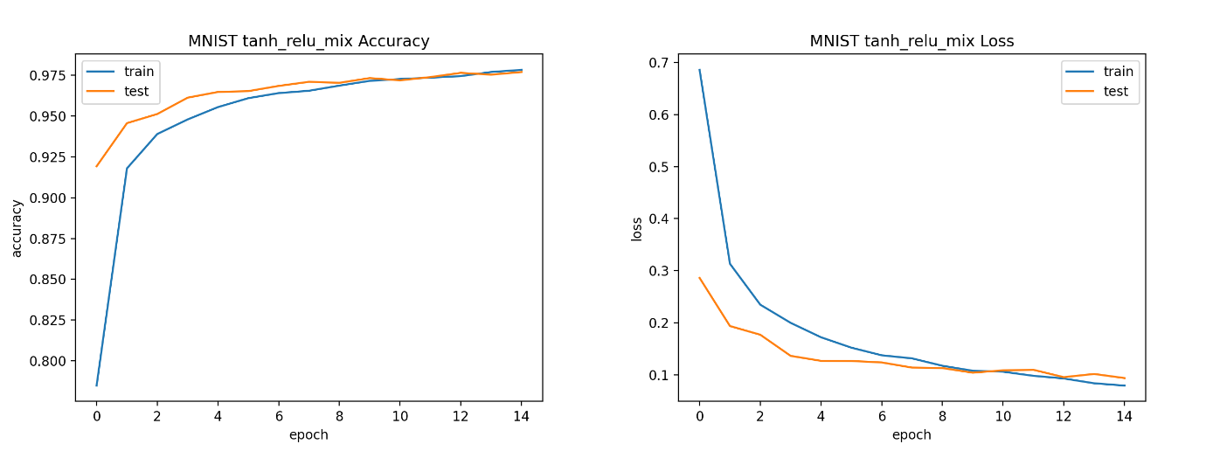
Figure 4.2.8: Accuracy & Loss Curves (Tanh + ReLU)—15 Epochs
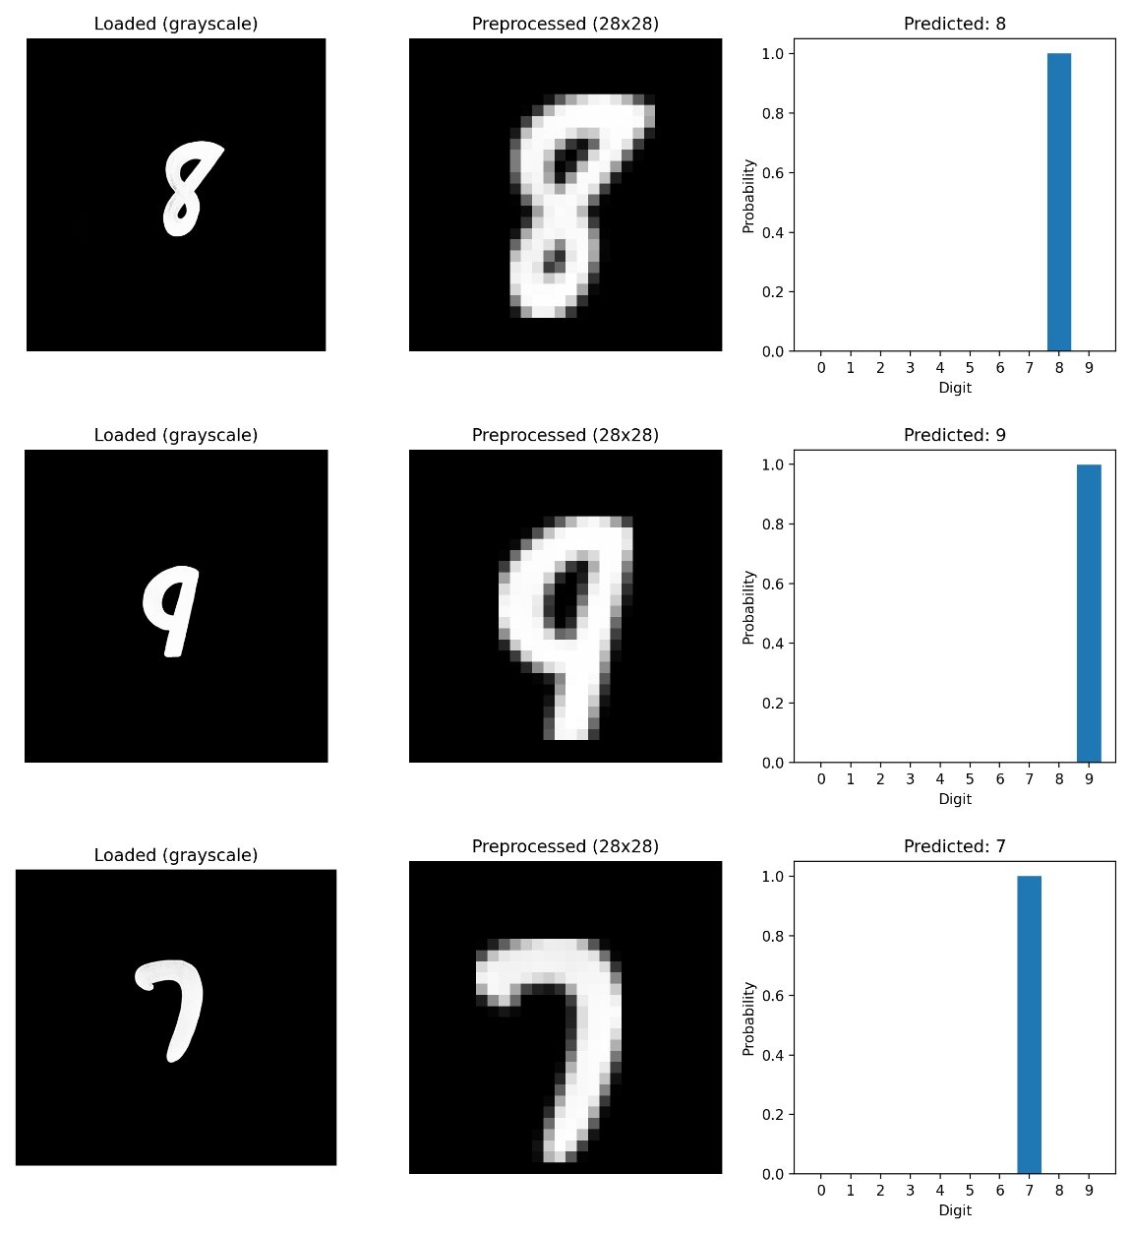
Figure 4.2.9: Handwritten (Output)—Tanh + ReLU
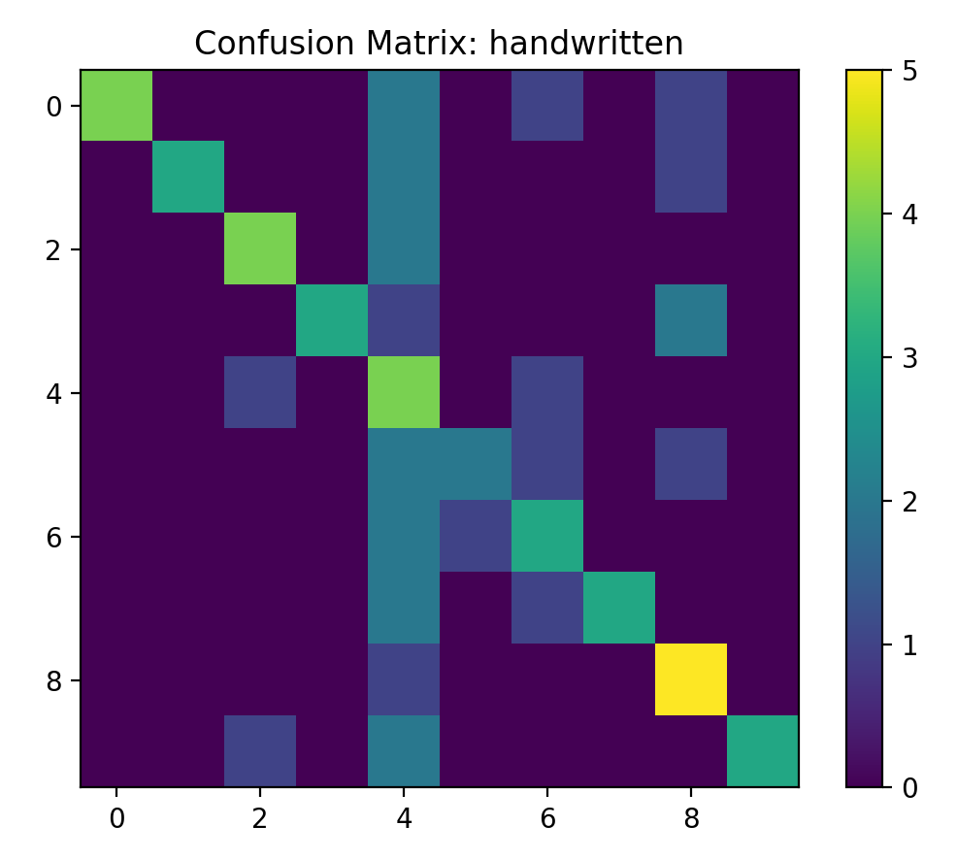
Figure 4.2.10: Confusion Matrix (ReLU)—handwritten
  - Interpretation of Findings
Overall, the extra tests confirm how crucial training time and activation function choice are to neural network performance. Extended training can slightly increase accuracy, but final performance and convergence efficiency are more heavily influenced by architectural decisions. These findings support the baseline analysis without changing the initial conclusions.

Conclusion
Using the MNIST dataset and several additional digit datasets, this study examined the performance of a fully linked Multi-Layer Perceptron for handwritten digit recognition. Under equal training settings, baseline trials comparing Sigmoid and Tanh activation functions revealed that Tanh consistently produced faster convergence and higher accuracy. ReLU-based networks achieved the highest MNIST test accuracy, especially when training was prolonged to fifteen epochs, according to longer trials using ReLU and mixed activation topologies. Evaluation on external handwritten and online digit datasets, however, showed a discernible decline in accuracy for all models, indicating poor generalization beyond benchmark data. These results highlight the discrepancy between controlled dataset performance and real-world applicability while also confirming that activation function selection has a major impact on learning dynamics and ultimate performance.
Because of their better gradient flow and convergence characteristics, this study suggests that ReLU or Tanh activations be used instead of Sigmoid for deeper fully linked networks. The discovered generalization restrictions imply that such models should not be used in real-world applications without additional precautions, despite their outstanding benchmark performance. Reducing ethical, dependability, and fairness issues requires more training data diversity, confidence-based decision thresholds, and human-in-the-loop validation. To increase resilience, future research should examine convolutional neural network topologies, data augmentation methods, and assessment on a wider range of datasets. Overall, the experiment shows that using neural networks to real-world digit recognition tasks successfully and ethically requires thorough evaluation, transparency, and mitigation techniques; high benchmark accuracy alone is insufficient for responsible deployment.

References
Ciresan, D., Meier, U. & Schmidhuber, J., 2012. Multi-column deep neural networks for image classification, s.l.: s.n.
Goodfellow, I., Bengio, Y. & Courville, A., 2016. Deep Learning. Cambridge, MA: MIT Press.
LeCun, Y., Bottou, L., Bengio, Y. & Haffner, P., 1998. Gradient-based learning applied to document recognition. Proceedings of the IEEE, 86(11), pp. 2278-2324.
Srivastava, N. et al., 2014. Dropout: A Simple Way to Prevent Neural Networks from Overfitting. Journal of Machine Learning Research, 15(56), pp. 1929-1958.

Appendices
Appendix A: Full Source Code
# Imports
import os, glob, random
import numpy as np
from scipy import ndimage
import torch
import torch.nn as nn
from torchvision import datasets, transforms
from torch.utils.data import DataLoader
from PIL import Image, ImageOps, ImageFilter
import matplotlib.pyplot as plt
from sklearn.metrics import confusion_matrix, classification_report

# Global Functions
def set_seed(seed=42):
random.seed(seed)
np.random.seed(seed)
torch.manual_seed(seed)
torch.cuda.manual_seed_all(seed)

def get_activation(name: str) -> nn.Module:
name = name.lower()
if name == "sigmoid":
return nn.Sigmoid()
if name == "tanh":
return nn.Tanh()
if name == "relu":
return nn.ReLU()
raise ValueError(f"Unsupported activation: {name}")

def nll_from_softmax_probs(probs, targets, eps=1e-9):
"""
probs: output of Softmax => shape [batch, 10]
targets: true class indices => shape [batch]
I'll compute log(probs) and apply NLLLoss.
eps is added for numerical stability to avoid log(0).
"""
log_probs = torch.log(probs + eps)
return nn.NLLLoss()(log_probs, targets)

# MLP Class
class MLP(nn.Module):
"""
Supports:
- activation: str ("sigmoid", "tanh", "relu") applied to all 6 hidden layers
- activations: list of 6 strings for per-layer mixed activations
- Output is ALWAYS Softmax.
"""
def __init__(self, activation="sigmoid", activations=None, dropout=0.2):
super().__init__()

layer_sizes = [
(784, 256),
(256, 256),
(256, 128),
(128, 128),
(128, 64),
(64, 32),
]

# Decide per-layer activations
if activations is None:
activations = [activation] * 6
if len(activations) != 6:
raise ValueError("activations must be a list of length 6 (one per hidden layer).")

blocks = []
for (in_f, out_f), act_name in zip(layer_sizes, activations):
blocks.append(nn.Linear(in_f, out_f))
blocks.append(get_activation(act_name))
blocks.append(nn.Dropout(dropout))

# Output layer (Softmax)
blocks.append(nn.Linear(32, 10))
blocks.append(nn.Softmax(dim=1))

self.net = nn.Sequential(*blocks)

def forward(self, x):
return self.net(x)

# MNIST Dataset Function
def get_mnist_dataloaders(batch_size=128):
tfm = transforms.Compose([
transforms.ToTensor(), # [0,1] range
transforms.Lambda(lambda x: x.view(-1)) # flatten 28x28 images to 784 vector
])
train_ds = datasets.MNIST("data", train=True, download=True, transform=tfm)
test_ds = datasets.MNIST("data", train=False, download=True, transform=tfm)
return(
DataLoader(train_ds, batch_size=batch_size, shuffle=True),
DataLoader(test_ds, batch_size=batch_size, shuffle=False)
)

# Per Epoch Function
def run_one_epoch(model, loader, optimizer, device, train=True):
model.train() if train else model.eval()
total_loss, correct, total = 0.0, 0, 0

with torch.set_grad_enabled(train):
for x, y in loader:
x, y = x.to(device), y.to(device)

if train:
optimizer.zero_grad()

out = model(x) # probabilities after Softmax
loss = nll_from_softmax_probs(out, y)

if train:
loss.backward()
optimizer.step()

total_loss += loss.item() * x.size(0)
pred = out.argmax(dim=1)
correct += (pred == y).sum().item()
total += x.size(0)

return total_loss / total, correct / total

# MNIST Dataset Training
def train_mnist(activation="sigmoid", activations=None, epochs=10, lr=1e-3, batch_size=128, seed=42):
set_seed(seed)
device = torch.device("cuda" if torch.cuda.is_available() else "cpu")
train_loader, test_loader = get_mnist_dataloaders(batch_size)
model = MLP(activation=activation, activations=activations, dropout=0.2).to(device)
optimizer = torch.optim.Adam(model.parameters(), lr=lr)

hist = {"train_loss": [], "train_acc": [], "test_loss": [], "test_acc": []}
best_acc, best_state = -1.0, None

for ep in range(1, epochs + 1):
tr_loss, tr_acc = run_one_epoch(model, train_loader, optimizer, device, train=True)
te_loss, te_acc = run_one_epoch(model, test_loader, optimizer, device, train=False)

hist["train_loss"].append(tr_loss); hist["train_acc"].append(tr_acc)
hist["test_loss"].append(te_loss); hist["test_acc"].append(te_acc)

tag = "MIXED" if activations is not None else activation.upper()
print(f"[{tag}] Epoch {ep:02d}/{epochs} | "
f"train loss={tr_loss:.4f} acc={tr_acc:.4f} | test loss={te_loss:.4f} acc={te_acc:.4f}")

if te_acc > best_acc:
best_acc = te_acc
best_state = {k: v.detach().cpu().clone() for k, v in model.state_dict().items()}
model.load_state_dict(best_state)
return model, hist, best_acc
# Saving curves of MNIST trained dataset
def save_mnist_artifacts(hist, out_dir, title_prefix):
os.makedirs(out_dir, exist_ok=True)

plt.figure()
plt.plot(hist["train_loss"], label="train")
plt.plot(hist["test_loss"], label="test")
plt.xlabel("epoch"); plt.ylabel("loss")
plt.legend(); plt.title(f"{title_prefix} Loss")
plt.savefig(os.path.join(out_dir, "loss_curve.png"), dpi=200)
plt.close()

plt.figure()
plt.plot(hist["train_acc"], label="train")
plt.plot(hist["test_acc"], label="test")
plt.xlabel("epoch"); plt.ylabel("accuracy")
plt.legend(); plt.title(f"{title_prefix} Accuracy")
plt.savefig(os.path.join(out_dir, "accuracy_curve.png"), dpi=200)
plt.close()

# Image Preprocessing using img
def preprocess_custom_image(path, invert_auto=True):
img = Image.open(path).convert("L") # grayscale
img = ImageOps.autocontrast(img)

if invert_auto and np.array(img).mean() > 127:
img = ImageOps.invert(img)

img = img.filter(ImageFilter.MaxFilter(3))

arr = np.array(img).astype(np.float32) / 255.0 # normalize to [0,1]
mask = arr > 0.15

labeled, n = ndimage.label(mask)
if n == 0:

arr28 = np.zeros((28, 28), dtype=np.float32)
return arr28.reshape(1, -1), arr28, img

sizes = ndimage.sum(mask, labeled, range(1, n + 1))
largest = 1 + np.argmax(sizes)
mask = (labeled == largest)
arr = arr * mask

coords = np.argwhere(mask)
y0, x0 = coords.min(axis=0)
y1, x1 = coords.max(axis=0) + 1
cropped = arr[y0:y1, x0:x1]

h, w = cropped.shape
scale = 20.0 / max(h, w)

new_w = max(1, int(round(w * scale)))
new_h = max(1, int(round(h * scale)))

# resize to 28x28

cropped_img = Image.fromarray((cropped * 255).astype(np.uint8)).resize((new_w, new_h), Image.BILINEAR)

canvas = Image.new("L", (28, 28), 0)
x_offset = (28 - new_w) // 2
y_offset = (28 - new_h) // 2
canvas.paste(cropped_img, (x_offset, y_offset))

arr28 = np.array(canvas).astype(np.float32) / 255.0

cy, cx = ndimage.center_of_mass(arr28)

shift_y = int(round(14 - cy))
shift_x = int(round(14 - cx))

arr28 = ndimage.shift(arr28, shift=(shift_y, shift_x), order=1, mode='constant', cval=0.0)

flat = arr28.reshape(1, -1)
return flat, arr28, img

# Prediction
def predict_one(model, path, out_dir):
os.makedirs(out_dir, exist_ok=True)
flat, img28, img_gray = preprocess_custom_image(path)

x = torch.tensor(flat, dtype=torch.float32)

device = next(model.parameters()).device
x = x.to(device)

model.eval()
with torch.no_grad():
probs = model(x)[0].detach().cpu().numpy()

pred = int(np.argmax(probs))

fname = os.path.splitext(os.path.basename(path))[0]
save_path = os.path.join(out_dir, f"{fname}_prediction.png")

plt.figure(figsize=(11, 4))
plt.subplot(1, 3, 1)
plt.imshow(np.array(img_gray), cmap='gray')
plt.title("Loaded (grayscale)"); plt.axis('off')

plt.subplot(1, 3, 2)
plt.imshow(img28, cmap='gray')
plt.title("Preprocessed (28x28)"); plt.axis('off')

plt.subplot(1, 3, 3)
plt.bar(range(10), probs)
plt.xticks(range(10))
plt.title(f"Predicted: {pred}")
plt.xlabel("Digit"); plt.ylabel("Probability")

plt.tight_layout()
plt.savefig(save_path, dpi=200)
plt.close()

return pred

# Folder evaluation
def evaluate_folder(model, folder, out_dir):
paths = sorted(glob.glob(os.path.join(folder, "*.*")))
if len(paths) == 0:
print(f"WARNING: No images found in folder: {folder}")
return 0.0

y_true, y_pred = [], []

for p in paths:
base = os.path.basename(p)
try:
true_label = int(base.split('_')[0])
except ValueError:
print(f"WARNING: Skipping file with invalid name format: {base}")
continue

pred = predict_one(model, p, out_dir)
y_true.append(true_label)
y_pred.append(pred)

acc = (np.array(y_true) == np.array(y_pred)).mean()

cm = confusion_matrix(y_true, y_pred)
rep = classification_report(y_true, y_pred, digits=4, zero_division=0)

with open(os.path.join(out_dir, "classification_report.txt"), "w", encoding="utf-8") as f:
f.write(rep)

plt.figure()
plt.imshow(cm)
plt.title(f"Confusion Matrix: {os.path.basename(folder)}")
plt.colorbar()
plt.savefig(os.path.join(out_dir, "confusion_matrix.png"), dpi=200)
plt.close()

return acc

# MNIST Sample grid
def save_mnist_sample_grid(out_path= "outputs/mnist_sample_grid.png", n=9, seed=42):
set_seed(seed)
os.makedirs(os.path.dirname(out_path), exist_ok=True)

tfm = transforms.ToTensor()
ds = datasets.MNIST("data", train=True, download=True, transform=tfm)

idxs = np.random.choice(len(ds), size=n, replace=False)

fig, axes = plt.subplots(3, 3, figsize=(6, 6))
for ax, idx in zip(axes.flatten(), idxs):
img, label = ds[idx]
ax.imshow(img.squeeze(), cmap='gray')
ax.set_title(f"Label: {label}")
ax.axis('off')

plt.tight_layout()
plt.savefig(out_path, dpi=300)
plt.close()
print(f"Saved MNIST sample grid: {out_path}")

# Best Accuray Summary
def save_accuracy_summary(results_dict, out_path="outputs/accuracy_summary.csv"):
os.makedirs(os.path.dirname(out_path), exist_ok=True)

# Determine folder columns
all_folders = sorted({folder for m in results_dict.values() for folder in m.keys()})
model_names = sorted(results_dict.keys())

with open(out_path, "w", encoding="utf-8") as f:
f.write("model," + ",".join(all_folders) + "\n")
for model in model_names:
row = [model]
for folder in all_folders:
val = results_dict[model].get(folder, "")
row.append(f"{val:.4f}" if isinstance(val, float) else "")
f.write(",".join(row) + "\n")
print(f"\nSaved accuracy summary CSV: {out_path}")
# MNIST Dataset Best Summary
def save_mnist_best_summary(rows, out_path="outputs/mnist_best_summary.csv"):
"""
rows: list of tuples [(model_name, best_acc), ...]
"""
os.makedirs(os.path.dirname(out_path), exist_ok=True)
with open(out_path, "w", encoding="utf-8") as f:
f.write("model,best_mnist_test_accuracy\n")
for name, acc in rows:
f.write(f"{name},{acc:.4f}\n")
print(f"Saved MNIST best summary CSV: {out_path}")

# Main Function ()
def main():
epochs = 15
batch_size = 128
lr = 1e-3

save_mnist_sample_grid("outputs/mnist_sample_grid.png")

# =========================
# BASELINE
# =========================

sig_model, sig_hist, sig_best = train_mnist("sigmoid", epochs=epochs, lr=lr, batch_size=batch_size)

save_mnist_artifacts(sig_hist, "outputs/mnist_sigmoid", "MNIST Sigmoid")

tanh_model, tanh_hist, tanh_best = train_mnist("tanh", epochs=epochs, lr=lr, batch_size=batch_size)

save_mnist_artifacts(tanh_hist, "outputs/mnist_tanh", "MNIST Tanh")

print("\nMNIST TEST ACCURACY (BEST) - BASELINE:")
print(f" Sigmoid: {sig_best:.4f}")
print(f" Tanh: {tanh_best:.4f}")

# =========================
# ADDITIONAL EXPERIMENTS
# =========================

extra_experiments = {
"relu_only": {"activation": "relu", "activations": None},

"sigmoid_tanh_mix": {"activation": "sigmoid",
"activations": ["sigmoid","sigmoid","sigmoid","tanh","tanh","tanh"]},

"tanh_relu_mix": {"activation": "tanh",
"activations": ["tanh","tanh","tanh","relu","relu","relu"]},

"sigmoid_tanh_relu_mix": {"activation": "sigmoid",
"activations": ["tanh","relu","sigmoid","tanh","relu","sigmoid"]},
}

extra_models = {}
extra_results = []

for name, cfg in extra_experiments.items():

model, hist, best = train_mnist(
activation=cfg["activation"],
activations=cfg["activations"],
epochs=epochs, lr=lr, batch_size=batch_size
)

save_mnist_artifacts(hist, f"outputs/mnist_{name}", f"MNIST {name}")
extra_models[name] = model
extra_results.append((name, best))

print("\nADDITIONAL EXPERIMENTS (BEST MNIST TEST ACC):")
for name, acc in extra_results:
print(f" {name}: {acc:.4f}")

mnist_rows = [("sigmoid", sig_best), ("tanh", tanh_best)] + extra_results

save_mnist_best_summary(mnist_rows, out_path="outputs/mnist_best_summary.csv")

# =========================
# EXTERNAL / CUSTOM TESTING
# =========================

tests = {
"word_blackbg": "custom_digits/word_blackbg",
"word_whitebg": "custom_digits/word_whitebg",
"paint_whitebg": "custom_digits/paint_whitebg",
"online": "custom_digits/online",
"handwritten": "custom_digits/handwritten"
}

models_to_test = {
"sigmoid": sig_model,
"tanh": tanh_model,
# optionally test extra models too:
**extra_models
}

print("\nCustom Folder accuracies (All Models):")

accuracy_results = {}

for model_name, model in models_to_test.items():
accuracy_results[model_name] = {}

print(f"\n--- Testing model: {model_name.upper()} ---")
for folder_name, folder_path in tests.items():
out_dir = os.path.join("outputs", "custom_tests", model_name, folder_name)
acc = evaluate_folder(model, folder_path, out_dir)

accuracy_results[model_name][folder_name] = acc
print(f" Folder: {folder_name} | Accuracy: {acc:.4f}")

save_accuracy_summary(accuracy_results, out_path="outputs/accuracy_summary.csv")

if __name__ == "__main__":
main()

Appendix B: GitHub Link & Execution Instructions (How to Run the Project)
B.1 System Requirements
- Python 3.8 or later
- Pip (Python package manager)
- Operating System: Windows, macOS, or Linux
B.2 Required Python Libraries
The project depends on the following Python packages:
- Torch
- Torchvision
- Numpy
- Scipy
- Matplotlib
- Scikit-learn
- Pillow
All dependencies can be installed using pip command.
B.3 Project Folder Structure
Porject_root/
|── mnist_project.py
|── data/ (auto-generated for MNIST)
|── custom_digits/
| |── handwritten/
| |── online/
| |── paint_whitebg/
| |── word_blackbg/
| |__ word_whitebg/
|── outputs/
|── Analytical_Report
The custom_digits folders must contain images named using the format:
- <label>_<anyname>.png
- e.g. 5_sample1.png
B.4 Environment Setup
- Creating a virtual environment:
  - py -m venv .venv
- Activate the environment:
  - .venv\Scripts\activate.ps1 (windows)
- Install dependencies:
  - Pip install torch torchvision numpy scipy matplotlib scikit-learn pillow
B.5 Running the Project
- py mnist_project.py
The script will automatically:
- Download the MNIST dataset
- Train baseline and additional models
- Save accuracy and loss curves
- Evaluate test on external digit datasets
- Generate CSV summaries and confusion matrices
B.6 Output Files
All results are saved in the outputs/ directory, including:
- Training curves (.png)
- Prediction visualizations
- Confusion matrices
- Accuracy summary CSV files
GitHub Link: Artificial Intelligence and Neural Network Portfolio

